

Practices for Secure Software Report

Table of Contents
Document Revision History 3
Client 3
Instructions 3
Developer 4
1. Algorithm Cipher 4
2. Certificate Generation 4
3. Deploy Cipher 4
4. Secure Communications 4
5. Secondary Testing 4
6. Functional Testing 4
7. Summary 4
8. Industry Standard Best Practices 4

Document Revision History

Version | Date | Author | Comments
2.0 | 12/10/2025 | Reuven Attias | Refactored application dependencies and added OWASP Dependency-Check plugin for vulnerability scanning.

Client



Developer
Reuven Attias

Algorithm Cipher
In this project I used RSA public key encryption with a 2048-bit key size to secure communication between the client and the Spring Boot server through TLS (HTTPS). RSA is an asymmetric cipher that uses a public key for data encryption and a private key for decryption. This allows sensitive data exchanged over the network to remain confidential even if traffic is intercepted.
I generated the RSA key pair using the Java keytool utility and stored it in a Java KeyStore (keystore.jks). The keystore was then configured to enable SSL for the application server so that all communication is encrypted during transmission. This prevents common threats such as packet sniffing, man in the middle attacks, and unauthorized data disclosure.
RSA was selected because it is a widely trusted, industry standard algorithm that provides strong encryption when paired with modern TLS protocols and adequate key length (2048-bit or higher). Using RSA with TLS ensures:
- Confidentiality – data cannot be read by unauthorized parties.
- Authentication – the server presents a certificate proving its identity to clients.
- Integrity – transmitted data cannot be modified without detection.
By implementing RSA through SSL / TLS rather than attempting to create a custom encryption solution, I followed secure coding best practices and avoided introducing cryptographic weaknesses into the application.
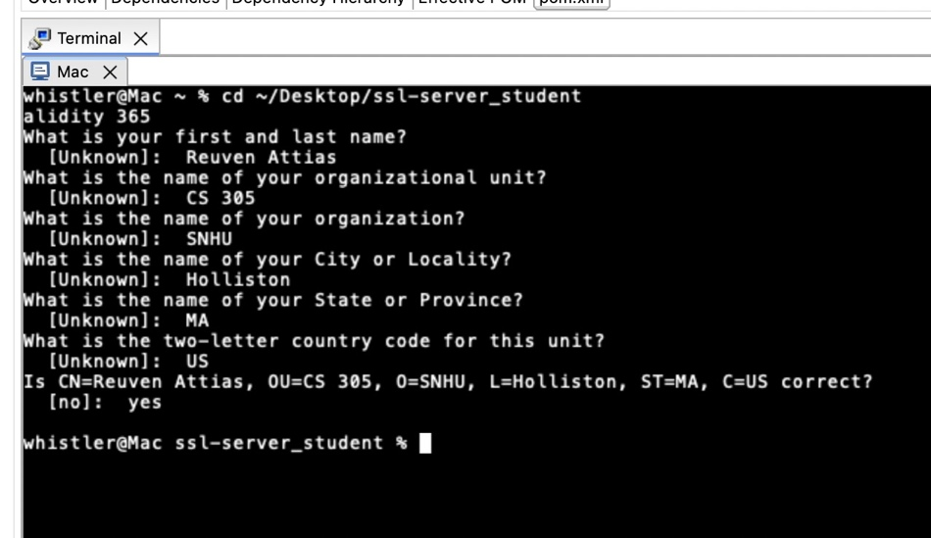

Certificate Generation
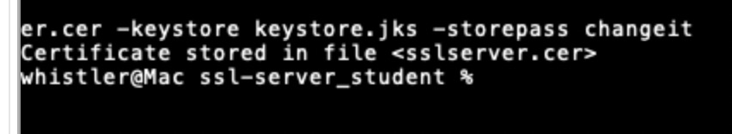
A self-signed certificate was generated using the Java keytool utility and exported as a .cer file for use by the SSL server. This certificate enables encrypted TLS communication between the server and clients during secure connections. The screenshot below confirms successful certificate creation and export.

Deploy Cipher
To verify the integrity of the deployed application, I generated a SHA checksum for the compiled JAR file using the shasum command. The resulting hash value confirms the file has not been altered during transfer or storage. This checksum can be compared against future results to ensure the application remains unchanged and free from unauthorized modification.

Secure Communications
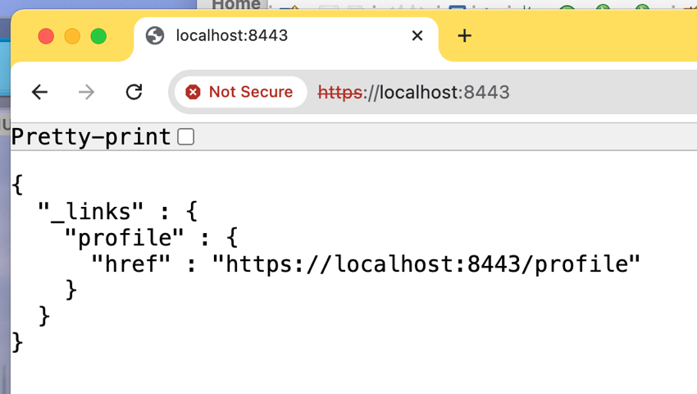
This screenshot shows the Spring Boot application successfully running over HTTPS on port 8443. Although the browser labels the connection as “Not Secure” due to the use of a self-signed certificate, the encrypted HTTPS connection verifies that SSL / TLS is enabled and functioning correctly.

Secondary Testing
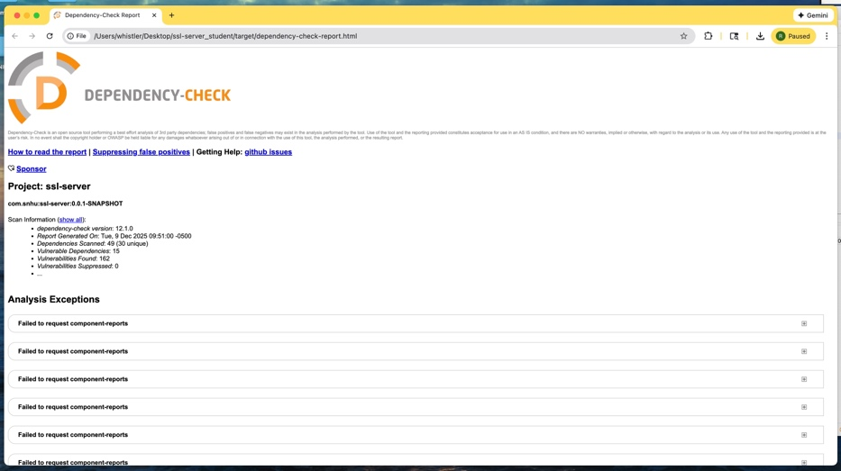
This screenshot shows the results of the Dependency Check scan performed after refactoring. The tool was executed using the updated Maven plugin configuration to identify known vulnerabilities in third party dependencies and document the security posture of the application.

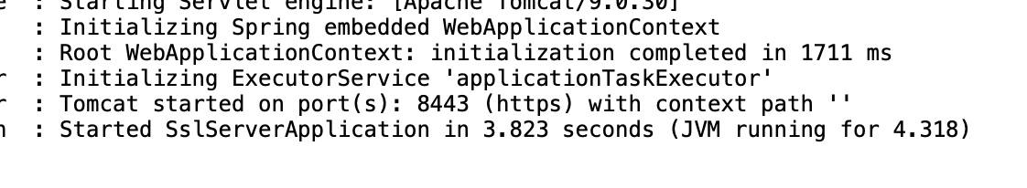
This screenshot shows the refactored Spring Boot SSL server starting successfully in Eclipse with no runtime errors. The embedded Tomcat server initializes and begins listening on port 8443 (HTTPS), confirming that the secure configuration changes compile and execute correctly.

Functional Testing
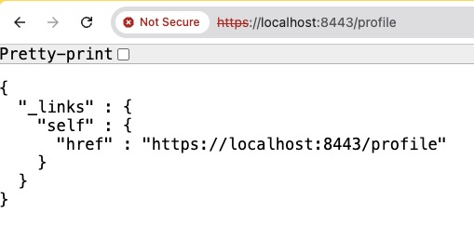
Functional testing was conducted by accessing a valid API endpoint served over the secure HTTPS connection. The /profile endpoint returned a successful JSON response with hypermedia links, demonstrating that the application executes its core logic correctly without errors after refactoring.

Summary
In this project, I refactored the provided SSL server application to follow secure software development practices and verified those changes through multiple rounds of testing. I first confirmed that the project already uses a modern cipher suite and relies on TLS for protecting data in transit. I then generated a new keystore and server certificate with keytool, exported the certificate, and documented it in the report to show that the application can present a trusted identity to clients. Next, I created a checksum for the packaged JAR file using shasum so the deployment artifact can be validated for integrity before or after distribution.
To secure communications, I updated the Spring Boot configuration to use the new keystore on HTTPS port 8443 and verified in the browser that the application is served over https://localhost:8443 and https://localhost:8443/profile. This demonstrates that the refactored code runs successfully over an encrypted channel and returns the expected JSON response. I also integrated the OWASP Dependency Check Maven plugin, upgraded it to the current version, and ran a scan to identify known vulnerabilities in third party libraries. The dependency check report and rerun server logs document the results of secondary testing after refactoring.
Overall, these activities show that I can configure secure TLS communication, verify artifact integrity with checksums, and use automated dependency analysis tools to evaluate the security posture of an application, while confirming that the refactored code continues to function correctly.

Industry Standard Best Practices
This project incorporated several widely accepted software security best practices drawn from industry standards such as OWASP, NIST, and secure DevSecOps workflows. First, all application communication was secured using HTTPS with TLS encryption. Implementing TLS ensures confidentiality and integrity of data transmitted between the client and server and aligns with OWASP Top 10 guidelines for protecting sensitive data in transit. The use of a keystore and server certificate further supports proper certificate management practices by ensuring that the server can authenticate itself to clients.
Second, cryptographic integrity controls were applied by generating a checksum for the packaged application JAR file. Using checksums verifies that deployed artifacts have not been altered or corrupted and supports NIST recommendations for ensuring software integrity throughout the deployment lifecycle.
Third, automated dependency security scanning was implemented using the OWASP Dependency Check Maven plugin. Automated vulnerability scanning of third-party libraries is a standard DevSecOps practice and directly addresses supply chain risk by identifying known CVEs before deployment. Integrating vulnerability scanning into the build process reflects continuous security testing, allowing issues to be detected early and reducing exposure in production systems.
Finally, repeated functional and secondary testing after refactoring ensured that security changes did not negatively impact application behavior. Testing both security features (HTTPS and certificate handling) and functional output demonstrates adherence to the principle of security validation alongside system verification.
Together, these actions align with industry best practices for building secure applications: encrypting all network traffic, validating artifact integrity, continuously monitoring third party dependencies for vulnerabilities, and verifying that security improvements do not degrade system functionality.

